买衣服：

School starts next week. You need to add proper attire to your wardrobe for the new school year. Work with your partner to skim through the advertisement provided by the teacher and decide what you will purchase to add to your wardrobe. Cut and paste the items, write out the items with the correct measure words. Don't forget to add the total.

我想买
Picture | Description | price
Ex. 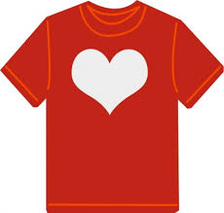 | 一件红色的T xù衫 | 十二块钱
一共____________________钱。

